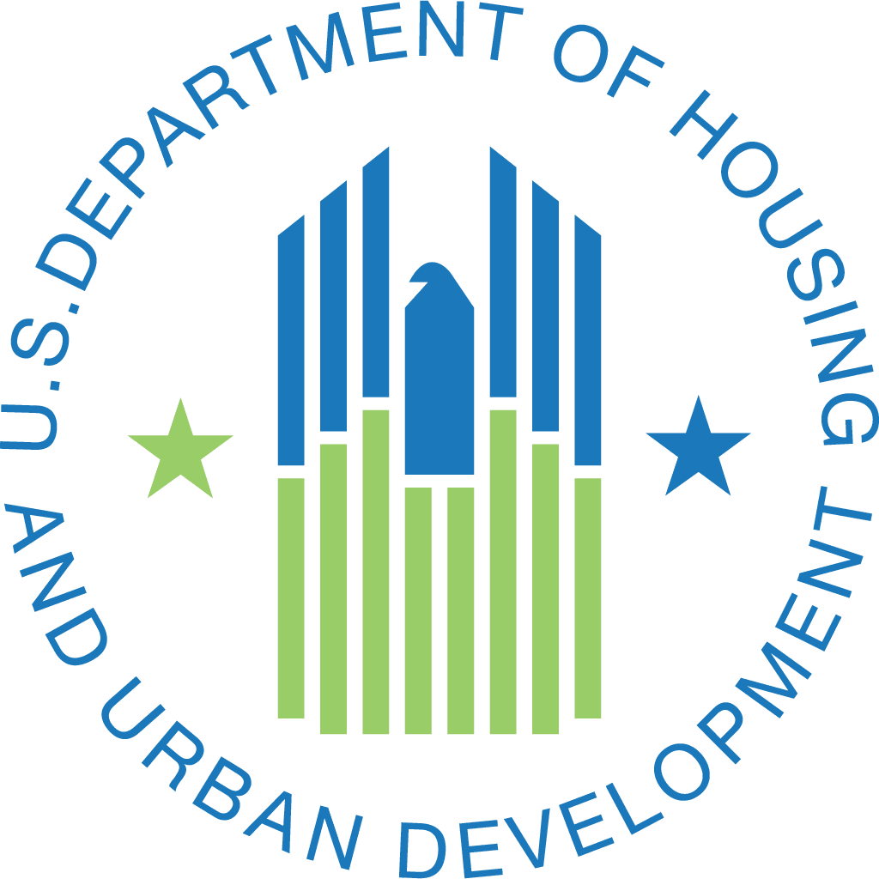

United States
Department of Housing and Urban Development
Build America, Buy America (BABA)
HUD’s Implementation of BABA

Frequently Asked Questions

Revised: 10/25/2023

Contents

Section 1: What is BABA? page 3
Section 2: Does BABA apply to me? page 4
Section 3: What is “infrastructure”? page 7
Section 4: How will BABA impact the products I purchase? page 8
Section 5: What if I am unable to find American made products? page 9

Sources

Executive Order 14005
Build America, Buy America Act
Environmental Protection Agency’s (EPA) FAQs
Implementation Notice
BABA Published Waivers on HUD’s Site
The Infrastructure Investment and Jobs Act
Department of Education’s (DOE) FAQs
Office of Management and Budget (OMB) M-24-02
Made in America Office (MIAO) 2 CFR 184

SECTION 1: What is BABA?

- What is the Build America, Buy America Act (BABA; “ba ba”)?
    - BABA is the Build America, Buy America Act. It was enacted on November 15, 2021, as part of the Infrastructure Investment and Jobs Act. In general, BABA requires that, when Federal agencies provide new “Federal Financial Assistance” (FFA), the Federal agencies impose a condition on the use of that FFA in an “infrastructure project” to make sure that all iron, steel, manufactured products, and construction materials used are subject to a domestic content procurement preference, which means that those items and materials were produced in the United States. This requirement to purchase materials made in America is called the “Buy American Preference” (BAP).
    - To learn about the Administration’s priority to maximize the use of products made in the U.S., please see Executive Order 14005.
- What is the purpose of BABA?
    - BABA is designed to bolster America’s industrial base, protect national security, and support high-paying jobs. Please see OMB Memorandum M-24-02 to learn more.
- What is the “Buy American Preference” (BAP)?
    - The “Buy American Preference” (BAP) is the “domestic content procurement preference.” The BAP requires that all iron, steel, manufactured products, and construction materials used in an infrastructure project funded by any Federal Financial Assistance (FFA) must have been produced in the United States.
- What is “Federal Financial Assistance”?
    - Under BABA, Federal Financial Assistance (FFA) includes any funding provided by the Federal government to a non-Federal entity (such as a state or local government, nonprofit, or tribe) that may be used for an infrastructure project. The BAP does not apply to funds used for disaster or emergency response infrastructure spending, such as CDBG-DR grants.
- What is the effective date of the BABA implementation?
    - The effective date for BABA implementation was May 14, 2022; however, HUD approved a waiver that extended the effective date for all programs until November 14, 2022.
    - HUD approved further extensions to the implementation dates through a Phased Implementation waiver that creates a schedule of when the BAP will apply to various HUD programs. For specific program application, please view the waiver here.
    - HUD has separately provided a waiver for applicable by all Tribal funding recipients through May 22, 2024.
- Does BABA apply to awards made before May 14, 2022?
    - No.
- Does BABA apply to awards made before November 14, 2022?
    - No; HUD approved a waiver exempting awards made between May 14, 2022 and November 14, 2022. The waivers may be reviewed here.
- My HUD program is impacted by HUD’s Phased Implementation waiver. Does BABA apply to me and, if so, when?
    - It depends. The effective date for BABA is May 14, 2022; however, HUD has specific effective dates for the application of all or parts of the BAP to HUD programs through FY2025 depending on the program and the product. HUD’s Phased Implementation Schedule can be viewed below or on the page “Does BABA Apply to Me?”

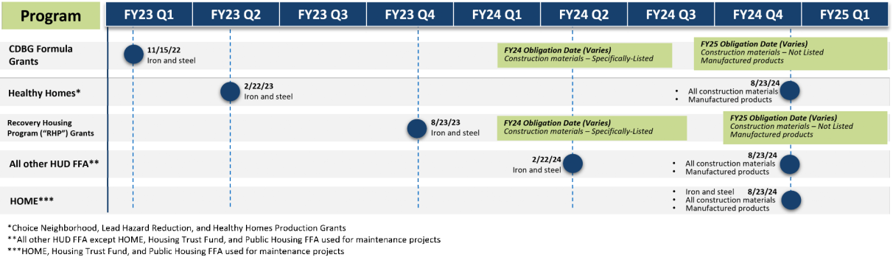

- Does BABA apply to amendments or renewals of awards made on or after November 14, 2022?
    - It depends. If HUD obligates any new or additional funds in connection with the amendment or renewal of prior awards, then all funds will be subject to BABA unless HUD grants a waiver. Any amendments made by a recipient using funds that it received from HUD before BABA became applicable, would not require the application of the BAP. However, if the recipient adds funds that are subject to the BAP to a project, the entirety of the project would be required to comply with the BAP unless HUD grants a waiver.
- Does BABA apply to no-cost amendments?
    - No. BABA requirements do not apply to no-cost amendments (i.e., no additional funding is added).
- Whom should I contact if I have additional questions about BABA?
    - For general waiver inquiries, please contact: BuildAmericaBuyAmerica@hud.gov.
    - For program-specific inquiries, please contact your local HUD Field Office.
- Does BABA apply to Tribal recipients?
    - HUD is currently in consultation with tribes regarding BABA. HUD has granted a waiver of BABA through May 22, 2024 while consultations are ongoing. The Tribal Consultation waiver can be found here. .
- Where can I find training on BABA and waiver submissions?
    - Any future trainings will be advertised on HUD’s BABA website. Any recordings of trainings will be posted on HUD’s BABA website. In the meantime, please contact your local HUD Field Office for more information on the waiver process. for more information on the waiver process.
- How long will BABA remain a requirement?
    - BABA was enacted into law with no expiration date.

SECTION 2: Does BABA apply to me?

- How will BABA impact recipients of FFA agreements (i.e., grants, cooperative agreements, and loans or subgrants/subawards)?
    - Generally, if you have received Federal Financial Assistance (FFA) through HUD for an infrastructure project after November 14, 2022, you must follow BABA requirements unless the application has been waived. This includes FFA used for the construction, maintenance, alteration, or repair of infrastructure.
    - HUD has issued several general applicability waivers that postpones the application of BABA requirements for most recipients. Please review the schedule of BABA implementation for HUD recipients here.
    - HUD has also issued general waivers of the application of the BAP in certain circumstances, such as in connection with small grants and for expenditures made in exigent circumstances. Please review these specific waivers here.
    - Additionally, BABA requirements do not apply to funds used for disaster or emergency response infrastructure spending, such as CDBG-DR grants. If you have questions about whether your expenditures qualify as disaster or emergency response, please contact your local Field Office.
- If I am a subrecipient of Federal Financial Assistance funding for infrastructure, does BABA apply?
    - Possibly. Recipients (the entities that receive FFA directly from HUD) that are subject to the BAP are required to notify and flow through BAP requirements to their subrecipients, unless HUD has issued an applicable waiver. Recipients must include the BAP in all subawards, contracts, and purchase orders for the work performed, or products supplied under the Federal award. The BAP flows down to subawards to subrecipients unless a particular section of the terms and conditions of the Federal award specifically indicate otherwise. Subrecipients should consult with the appropriate recipient and consult their specific agreements to determine whether their funding is subject to the BAP.
    - Recipients receiving FFA covered by BABA are responsible for making sure their subrecipients follow BABA unless the application of BABA has been waived by HUD.
- Does BABA apply to small grants?
    - BABA requirements apply to all infrastructure projects funded with Federal Financial Assistance (FFA) provided by HUD after November 14, 2022, unless a waiver applies.
    - HUD has issued a waiver for infrastructure grants and expenditures whose total cost is equal to or less than the current Simplified Acquisition Threshold of $250,000.
    - HUD has issued a waiver for a “De Minimis” portion of an infrastructure project, waiving BABA requirements for a cumulative total of no more than 5 percent of the total cost of the iron, steel, manufactured products, and construction materials, up to a maximum of $1 million.
    - Information about the De Minimis and Small Grants Waiver can be found here.
- I just received BABA funding, but I’ve already built some of my infrastructure project with funding that is not subject to BABA (e.g., foreign-produced steel). How do I remain in compliance with BABA?
    - The recipient may seek a waiver for the addition of supplemental funding by visiting the HUD BABA Website. If a recipient adds funds subject to BABA to an existing project, all project funding becomes subject to BABA. This is true even if the existing project was not originally subject to BABA.
- Which HUD programs are subject to BABA requirements?
    - Any HUD program that provides Federal Financial Assistance (FFA) for the construction, maintenance, alteration, or repair of infrastructure as defined in BABA is subject to BABA requirements once fully implemented by HUD. However, BABA requirements do not apply to funds used for disaster or emergency response infrastructure spending, such as CDBG-DR grants. For more information, please refer to the Phased Implementation Waiver here. For more information about what constitutes disaster or emergency response spending, please contact your local Field Office..
- What would cause a HUD program to change BABA applicability status?
    - BABA applicability may be affected by a waiver granted by HUD or if eligible uses of funding under the given HUD program change.
    - Additionally, if changes are made to the relevant definitions in 2 CFR 200, the applicability of BABA may change.
- Is Force Account Labor subject to BABA?
    - No. The use of Force Account Labor does not affect BABA applicability.
    - Force Account Labor is the use of directly hired staff to carry out eligible activities under a program instead of procuring services through contract. The applicability of BABA is not determined by how eligible activities are performed.
    - However, work performed using Force Account Labor may require the application of the BAP to the purchase of the materials used in the project.
- I have questions about waiver applicability for Co-Funded Projects (subject to BABA). When a project receives funding from multiple FFA programs, how will the funding recipient determine which general applicability waivers or adjustment period waivers apply?
    - The determination of the applicability of BABA will be on a case-by-case basis. In general, where the BAP is applicable, it will apply to all the FFA used in the project, regardless of which program provides the funds. Different sources of Federal Funds may have different timelines, obligations, or applicable waivers under BABA, so the recipient must ensure it is clear whether any of the FFA being used requires the application of the BAP. Moreover, HUD waivers do not affect the applicability of BABA in connection with other sources of Federal Funds. Even where HUD has not yet required application of the BAP or has waived its applicability, if another agency requires compliance, the entire project must comply with the applicable requirements.
- I have questions about the waiver applicability for Co-Funded Projects (with funding from multiple Federal agencies). When a project receives funding from Federal assistance programs in multiple agencies (e.g., EPA and USDA; EPA, FEMA, and DOT), how will potentially different generally applicability or adjustment period waivers be implemented?
    - You should inform HUD if other Federal programs are funding or will fund your project. If so, HUD will coordinate with those co-funding agencies to determine the optimal approach for your project. This approach will focus on BABA applicability, use of waivers, and minimizing disruption to your project.
- I have funding from multiple Federal sources and need a waiver. Do I have to apply for a waiver from every agency contributing funding?
    - Possibly. In order for a project to be excluded from BABA requirements, each agency contributing funding must have issued a waiver that is applicable for its funding. Agencies may have standing waivers that are applicable, or the funding recipient may need to seek a waiver from each funding source.
    - Federal agencies are working to develop a process to streamline this for recipients.
    - Note that each agency will issue a separate waiver for your project.

SECTION 3: What is “infrastructure”?

- How does BABA define “infrastructure”?
    - According to 2 CFR 184.4(d), recipients should define “infrastructure” to include the structures, facilities, and equipment for, in the United States—(A) roads, highways, and bridges; (B) public transportation; (C) dams, ports, harbors, and other maritime facilities; (D) intercity passenger and freight railroads; (E) freight and intermodal facilities; (F) airports; (G) water systems, including drinking water and wastewater systems; (H) electrical transmission facilities and systems; (I) utilities; (J) broadband infrastructure; (K) buildings and real property; and (L) structures, facilities, and equipment that generate, transport, and distribute energy including electric vehicle (EV) charging.
    - In general, the Federal awarding agency would consider whether the project will serve a public function, including whether the project is publicly owned and operated, privately operated on behalf of the public, or is a place of public accommodation, as opposed to a project that is privately owned and not open to the public.
- What doesn’t the Buy America preference apply to?
    - BABA applies to Federal Financial Assistance provided to Non-Federal Entities when used in connection with an infrastructure project. For the purposes of BABA, FFA does not include Federal funding used for pre or post disaster or emergency response expenditures, like CDBG-DR.
    - According to 2 CFR 184, BABA only applies to articles, materials, and supplies that are consumed in, incorporated into, or affixed to an infrastructure project.
    - BABA requirements do not apply to:
      - Tools, equipment, and supplies, such as temporary scaffolding, brought to the construction site and removed by the completion of the infrastructure project.
      - Equipment and furnishings, such as movable chairs, desks, and portable computer equipment, that are not an integral part of or permanently affixed to the structure.
      - For more guidance on definitions, please refer to the 2 CFR 184 or 2 CFR 200.
- How does BABA define “Project”?
    - BABA defines "project” as any activity related to the construction, alteration, maintenance, or repair of infrastructure in the United States. Specific guidance on how to define the project for purposes of BABA will be provided by the individual programs providing FFA.
- If most of the project uses American made products and a small portion does not, what should I do?
- In this case, you may be able to rely on HUD’s “De Minimis” waiver. For this waiver, the requirement to buy American made products does not apply for a De Minimis portion of an infrastructure project. A De Minimis portion is a cumulative total of no more than 5 percent of the total cost of the iron, steel, manufactured products, and construction materials used in or incorporated into the infrastructure project, up to a maximum of $1 million.
- For more information on the De Minimis and Small Grants Waiver refer here.

SECTION 4: How will BABA impact the products I purchase?

- How can I find products that are made in America?
    - Currently there is no official label or certifying body for BABA compliant products. When reviewing products to determine if they are made in America, please refer to the definitions for American made products stated in 2 CFR 184.
    - You may find American made products by working with the Hollings Manufacturing Extension Partnership (MEP), Trade associations, and local manufacturers/stores.
    - Please refer to the Q&A below for examples.
    - For additional information and the latest resources, please check the Made in America Office website.
- For iron and steel products, does a manufacturer need to demonstrate compliance from initial melting through the finished product?
    - Yes. According to 2 CFR 184, all iron and steel used in the project must have been produced in the United States. This means that all manufacturing processes, from the initial melting stage through the application of coatings, occurred in the United States.
    - For additional information and the latest resources, please check the Made in America Office website.
    - For more guidance on definitions, please refer to the 2 CFR 184 or 2 CFR 200.
- For products made of iron and steel, what is the difference between predominantly and primarily iron and steel?
    - According to 2 CFR 184, there is no difference between predominantly and primarily iron and steel for the purposes of BABA.
    - For additional information and the latest resources, please check the Made in America Office website.
    - For more guidance on definitions, please refer to the 2 CFR 184 or 2 CFR 200.
- What is the definition of construction materials (with examples)?
    - The Made in America Office of OMB defined “construction materials” in 2 CFR 184.6. “Construction materials” are defined as articles, materials, or supplies that consistent of only one of the following items: non-ferrous metals, plastic and polymer-based products (including polyvinylchloride, composite building materials, and polymers used in fiber optic cables), glass (including optic glass), fiber optic cable (including drop cable), optical fiber, lumber, engineered wood, and drywall.
    - Minor additions of articles, materials, supplies, or binding agents to a construction material do not change the categorization of the construction material.
    - For additional information and the latest resources, please check the Made in America Office website.
- What are manufactured products?
    - “Manufactured products” is defined in 2 CFR 184.3. “Manufactured products” are articles, materials, or supplies that have been processed into a specific form and shape or combined with other articles, materials, or supplies to create a product with different properties than the individual articles, materials, or supplies.
    - Unless another law or standard applies to you, “manufactured products” that are compliant with BABA meet the following criteria:
      - Manufactured in the United States; and,
      - The cost of the components of the manufactured product that are mined, produced, or manufactured in the United States is greater than 55 percent of the total cost of all components of the manufactured product.
    - Please continue to check the Made in America Office website for updates.
- Are products and materials that purposefully decay or decompose (such as biodegradable coir material used for erosion control) considered permanently affixed items that are subject to the BABA requirements?
    - No. According to 2 CFR 184, BABA requirements do not apply to non-permanent fixtures. See Section 3 Question 2 of this FAQs list for more detail.
    - For additional information and the latest resources, please check the Made in America Office website.
    - For more guidance on definitions, please refer to the 2 CFR 184 or 2 CFR 200.

SECTION 5: What if I’m unable to find American made products?

- What if I am unable to find American made products?
    - If you are unable to find American made products, then you may seek a waiver. Before requesting a new waiver from HUD, first check that none of the existing waivers are sufficient to cover your situation. HUD may waive your requirement to use American made product(s) if it finds that:
      - Requiring the use of the American made product would be inconsistent with the public interest;
      - The product you need is not produced in the United States in sufficient quantities or of a satisfactory quality; or,
      - The inclusion of the product produced in the United States will increase the cost of the overall project by more than 25 percent.
    - HUD reviews waivers before they are posted to the Federal Register for public comment and sent to MIAO for approval.
- How do I apply for a waiver?
    - Please visit the HUD BABA Website.
- What types of general waivers has HUD already issued that may apply for all HUD recipients?
    - For a summary of HUD’s current general waivers, please refer to the below table. HUD’s current list of general waivers can be found here.
    - Moreover, HUD has specific effective dates for the application of all or parts of the BAP to HUD programs through FY2025 depending on the program and the product. HUD’s Phased Implementation Waiver can be viewed here.

General Waivers
Small Grants | De Minimis | Exigent Circumstances | Tribal Consultation
BABA requirements do not apply to infrastructure projects whose total cost is equal to or less than the current Simplified Acquisition Threshold of $250,000. This waiver is currently in effect as of November 23, 2022. | BABA requirements do not apply for a De Minimis portion of an infrastructure project, meaning a cumulative total of no more than 5 percent of the total cost of the iron, steel, manufactured products, and construction materials, up to a maximum of $1 million. This waiver is currently in effect as of November 23, 2022. | This waiver applies when there is an urgent need by a recipient to immediately complete an infrastructure project because of a “exigent circumstances,” or a threat to life, safety, or property of residents and the community. This waiver is currently in effect as of November 23, 2022. | This waiver is effective for Tribal recipients through May 22, 2024. HUD issued a public interest waiver for the BAP as it applies to Tribal recipients to allow time for HUD to consult with Tribally Designated Housing Entities, and other Tribal Entities on how to apply the BAP.

- What should I do if I am covered by a program-wide waiver? Do I need to maintain documentation?
    - Yes. You should maintain appropriate documentation, consistent with the program guidance for your specific award.
- Who may apply for a waiver and how do you apply?
    - Recipients subject to BABA may apply for a waiver. For a summary of BABA waivers and information needed to apply for these waivers, refer to the below table. Please contact your local HUD Field Office to apply.

Project/Product-Specific Waivers
Non-Availability | Unreasonable Cost | Public Interest
For this type of waiver to be granted, HUD must determine that it will waive BABA requirements because HUD and agrees that the product needed is not produced in the United States in sufficient quantities or of a satisfactory quality.  In their waiver request, recipients should:  - Demonstrate that they have conducted market research and adequately considered qualified alternate items.  - Describe the due diligence performed, including information, quotes, and/or responses from manufacturers, distributors, or suppliers. | For this type of waiver to be granted, HUD must determine that it will waive BABA requirements because the adherence to BABA requirements will increase the cost of the overall project by more than 25 percent.  In their waiver request, recipients should:  - Demonstrate that BABA compliance increases total project cost by more than 25%.  - Determine the additional cost of BABA compliant products.  - Determine the dollar amount to be waived.  - Demonstrate that no domestic alternatives are available within the project budget. | For this type of waiver to be granted, HUD must determine that it will waive BABA requirements requiring compliance with such requirements is inconsistent with the public interest.  In their waiver request, recipients should:  - Explain how waiving the BABA requirement for this project or product serves the public interest.  - Demonstrate definite impacts on the community if specific items, products, or materials are not utilized in an infrastructure project.

- Can I submit one waiver submission that encompasses multiple projects?
    - If you are seeking a product-specific waiver for an item you will use in multiple projects, you may be able to submit one product waiver depending on your circumstances. If you are seeking a project-specific waiver, you must submit one waiver per project. If you are seeking a public interest waiver, the circumstances will dictate the number of waivers, but you generally would not be required to submit multiple requests for the same waiver.
- How will I know if my waiver is accepted or denied?
    - HUD will inform you once the Department has approved or denied your waiver. If approved, your waiver will also be posted in the Federal Register and on Made in America Office (MIAO) websites. You may track the final decision on these websites.
- How can I check the status of my waiver application?
    - Contact your local HUD Field Office.

