LEARNING FROM VOUCHER FAMILIES: BARRIERS AND OPPORTUNITIES TO MOBILITY
Philip ME Garboden
Johns Hopkins University
in collaboration with
Stefanie DeLuca
Johns Hopkins University
Jennifer Darrah-Okike Peter Rosenblatt
Johns Hopkins University Loyola University of Chicago

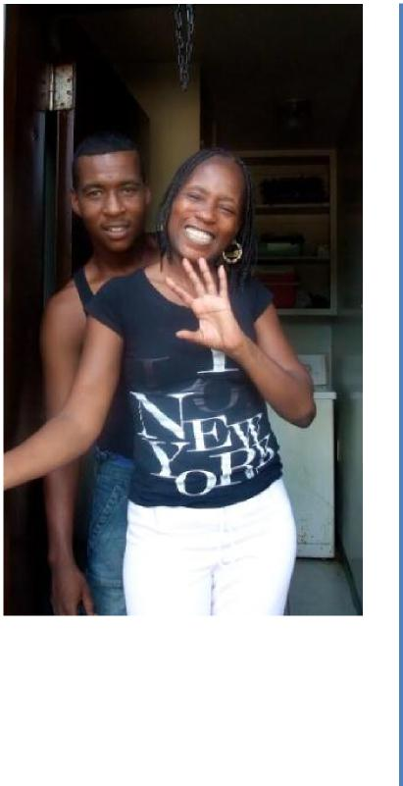 | Why Are Section 8Voucher Families Concentrated  in Poor, Segregated Areas?  Cost and Fair Market Rent Limits  Policy Limitations (such as Portability)  Supply of Rental Housing  Discrimination  Families “Choose” Neighborhoods  Social ties and networks  Racial in-group preferences

Talking To Families
Field work with poor African American parents with children
2009, 2010, 2011, 2012, 2013 Interviews and Home Visits
Mobile, AL and Baltimore, MD (N=235)
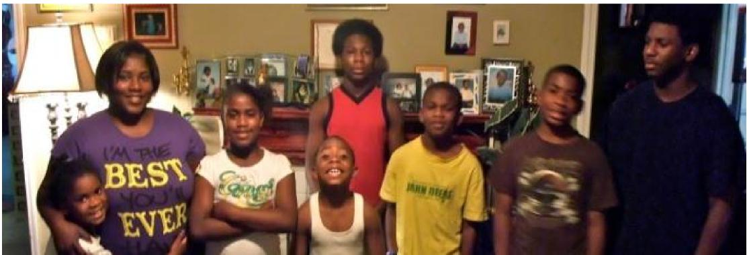
Reactive Mobility: The Time Crunch
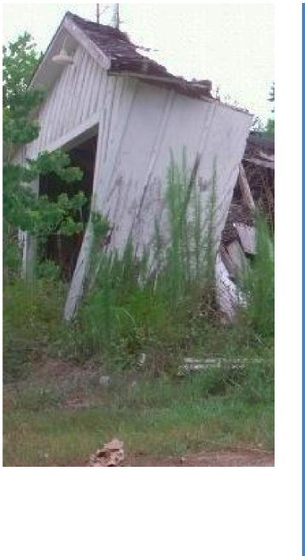
That house was only a six-month stay as well. Because they had to come out and re-inspect. .. Where you couldn’t turn the stove all the way off. Cause if you did, the pilot would go out. Not only that, you have your bathroom, the toilets, everything just leaking around. And it just was a house that should have never passed.
(But you had to take it?)
I HAD to take it because I only had ten days left on my voucher.. .the landlord wouldn’t come and make the repairs that he had promised.. .They came out and they did another inspection, and they found that it should have never passed again, and I would have to move.
Reactive Mobility: Unit Failure
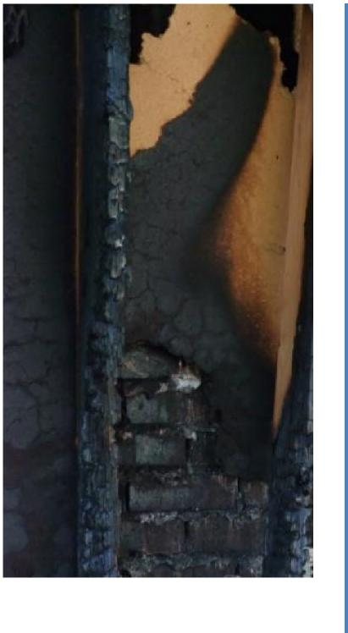
[O]ur whole ceiling came in on us. In my daughter’s room, every time it would rain, it would leak and we would tell the landlord, like,“Please come fix it!” We would go to home depot and try to get things to fix it, still wouldn’t work. Luckily [my daughter] was gone for the weekend and boom! And it all fell down.
Reactive Mobility: Landlords
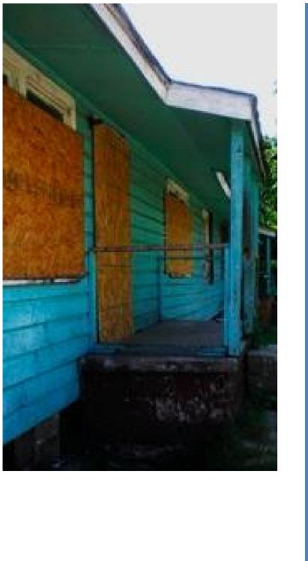
Molly: We came out here and looked at the house. It was awful. The carpet was flooded, it had a bad odor, lots of bugs in it. But I looked through the house, it’s a nice house, it had 4 bedrooms, two baths and I told him I wanted it. What I did is I had a social worker and he had brought some children, they were volunteers, they came in here and pulled all the carpet up.
(Did you have to pay for that?)
Molly: No, he put down new carpet. But he wasn’t putting down everything... That screen there, that was 250. I put it in the front and in the back. [The property manager], they wanted to give me back my $500 deposit, they told me they were fixing nothing. I had to do it all.
The Housing Search
A friend of mine found that house for me. He knew the landlord so he talked to the landlord and told [him] what was going on. So he gave me the house. Then the next thing I know he like I got to move because he trying to sell it. He’s bringing people there to look at the house when I was still living there
It’s not like you can ride in Owings Mills [a suburban community] like riding through the city looking for a place. Cause it’s the county, things are dipped off.
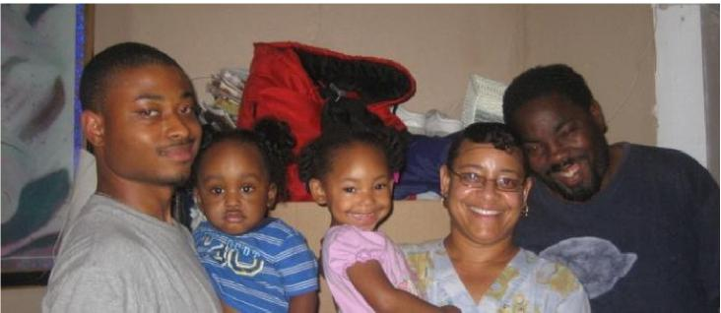
The Housing Search: Discrimination
I would have to call first just to see if they did accept [my voucher]; if they didn’t, then I already knew. I did that with everything – I don’t care what it is. Now when I got a car, I’m not just gonna jump in my car and go somewhere without calling first and like... you know, get the information I need.
People, some people frown on stuff like [Section 8] and they really don’t want to rent to [us]... and I think that a lot of people think that people that’s on Section 8 are ignorant and they just trifling and don’t want nothing out of life. That’s not really the case. Some people just need a little help.
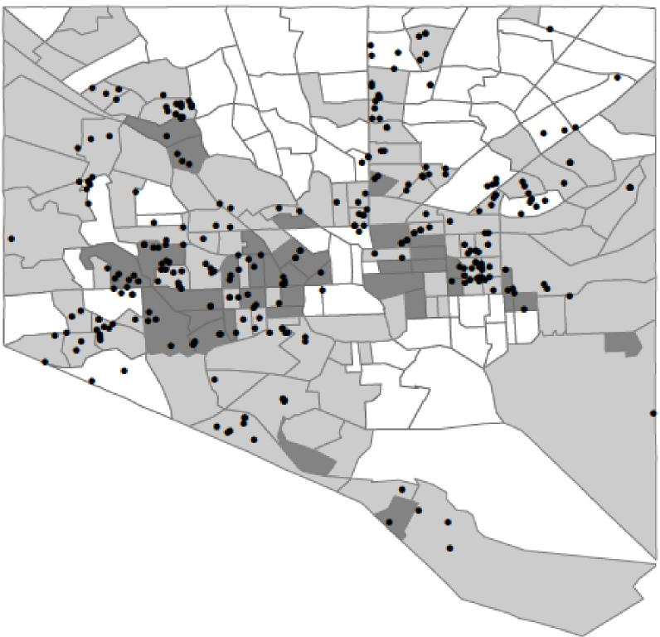
GoSection&com Listings, Baltimore

6
Legend
- GoSection8.com Listirg
Tract Poverty Rate
low poverty
moderate poverty high poverty
Sources: 2011 American Cm⁻murky Survey, GoSecticoa. Dorn
Strategic Retreat
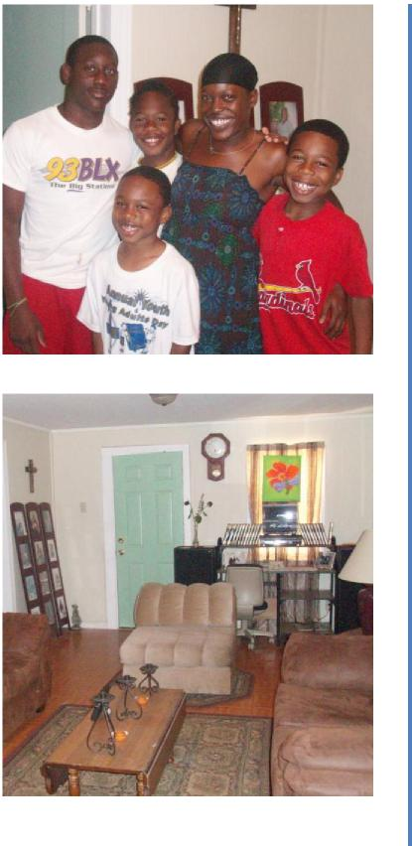
I really don’t let them play in the street or in the yard or anything like that. I don’t trust it. I know last year my daughter wanted to go outside and I was about to let her go and on the next corner three people got shot right there in broad daylight. So ever since...I don’t let her go outside.
I’m to myself...I don’t want you comin in and knock on my door, can you borrow this, nothin, cause I don’t borrow nothin from you.
I love my little place, but I don’t like the environment and I tell my children...It’s not where you live, it’s how you live. You know, we don’t live outside, we live in here...
What Limits Mobility?
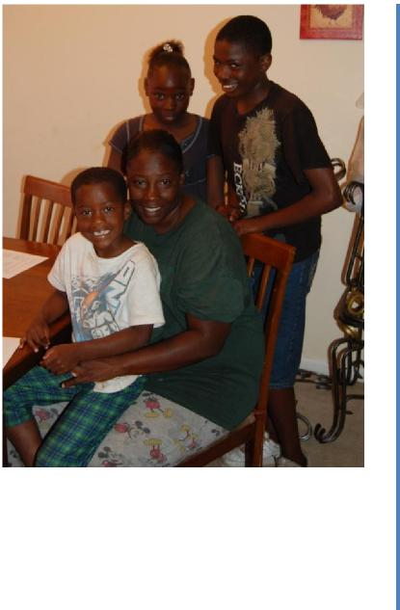
Housing quality, landlords, family dynamics all lead to reactive mobility
Aspects of housing policy create instability and churning Housing search methods and discrimination
Lack of information and long-term exposure to high poverty areas leads families to develop coping strategies and low expectations
BUT

I’m a city girl, but I’m also a county girl now.

Individual Neighborhood Poverty Trajectories: Qualitative Sample

90

70  't  60  )  0  0.  3 0 ti co 50 41 tip  10 V C CP U  ^{l}il  2. 40  U  10  I: N 2 N C 11) 30 U  20  10 | 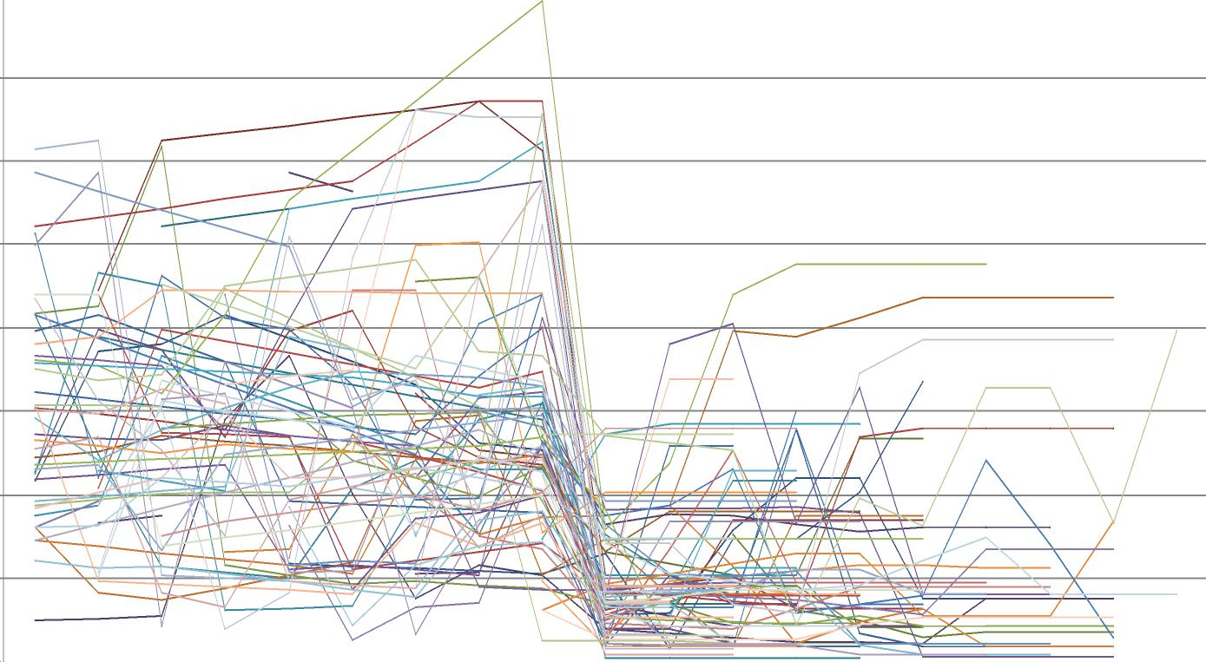

-9 -8 -7 -6 -5 -4 -3 -2 -1 0 1 2 3 4 5 6 7 8 9
Years Post Thompson Move

New Opportunities
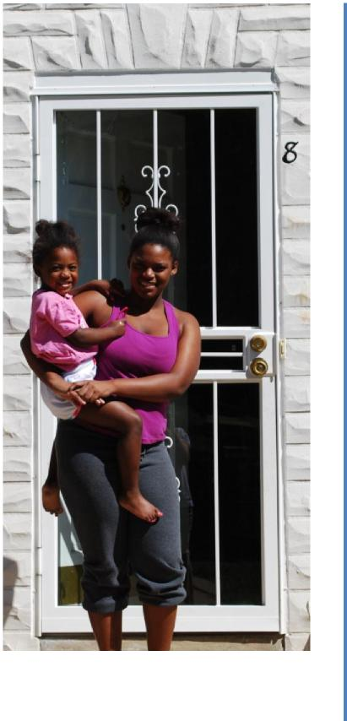
You have to understand I came from the projects to the suburbs. At one time I was kind of going crazy but knew that it was the best thing for me, so I knew that I had to deal with it and get used to it. You know, I kind
of wish that I was raised there, born and raised there... County girls are used to the peacefulness, the quietness, the isolation, whereas the city girls are used to getting up... What I mean by that is you had corner stores. You know, if I wanted a bag of potato chips I could get up
and just walk right here... It’s a difference like no other.
But, I’m a city girl but I’m also a country girl now.
New Opportunities: Schools
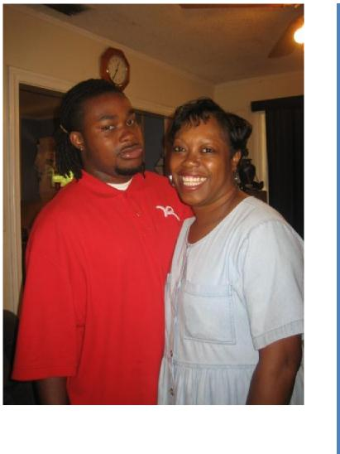
I hated this [second] house, but I didn't want to take the boys out of the school that they were in so I moved here...because I didn't want to change them from another school and I like the school that they're in.
New Opportunities: Work
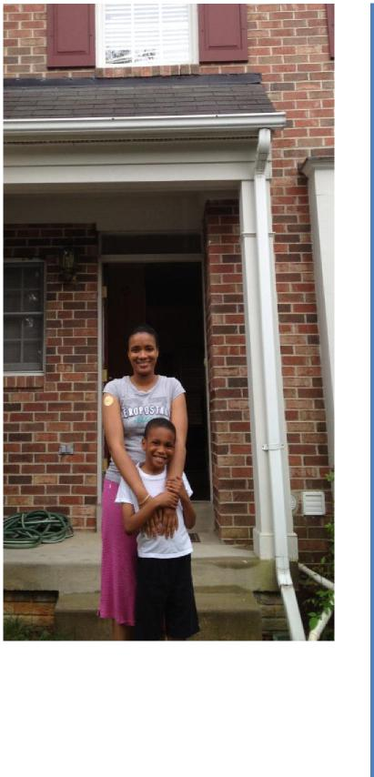
And I'm ready to try to get myself back into some type of, like I said some type of program and things, and I'm more focused here. Because living there [in public housing] I was like on track, off-track, on track, off-track because it is so much that was going on around me... I was so more focusing on praying to get out of there, that I really couldn't focus on too much else. Of course I'm focusing on my kids, but for the things that I wanted to do for myself, I couldn't stay focused. So now I’m somewhere where it’s peace and quiet, and now I can stay more focused.
Thank you.

