SAMPLE LETTER TO OWNER/AGENT (POST REVIEW)
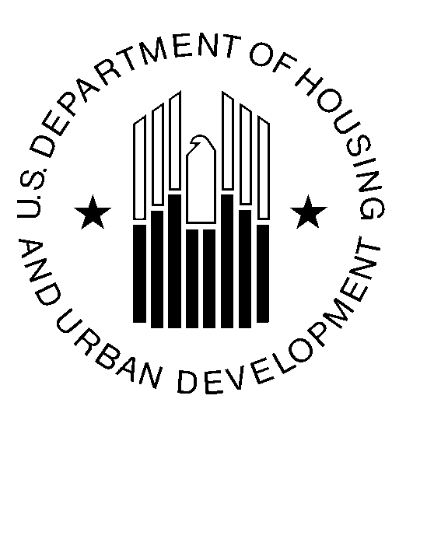

U.S. Department of Housing and Urban Development

November 1, 2007

James E. Wills, Vice President of Operations
Wills Management Group
1234 New York Avenue, N.E.
Washington, D.C. 20015

Re: Comprehensive Management Review Report
Capital Heights Apartments
FHA #000-35333

Dear Mr. Wills:

The enclosed report reflects the results of a comprehensive Management Review of Capital Heights Apartments conducted by my staff on October 1, 2007. This type of review is conducted periodically to determine compliance with HUD’s Regulations and the owner’s established management procedures and practices. Please note that your review reflects the following ratings:

Category Ratings

General Appearance and Security Superior
Follow-up Project inspection Superior
Maintenance/Operating Procedures Satisfactory
Financial Management Unsatisfactory
Leasing & Occupancy Not Rated
Tenant/Management Relations Not Rated
General Management Practices Satisfactory
Overall Rating Unsatisfactory

The overall rating of Unsatisfactory is due to the rolling default of the mortgage noted under financial management. The findings cited in the enclosed report should be addressed in accordance with the required corrective actions, and a written response submitted in writing to this office within 15 days from the date of this letter.

If you have any questions regarding this report please call Project Manager, Senior Project Manager at (202) 575-5700 ext. 8000 or by email at: ProjectManager@hud.gov.

Sincerely,

(Name)
Multifamily Hub Director

Enclosure
- Management Review Report

