SAMPLE CLOSEOUT LETTER TO OWNER/AGENT
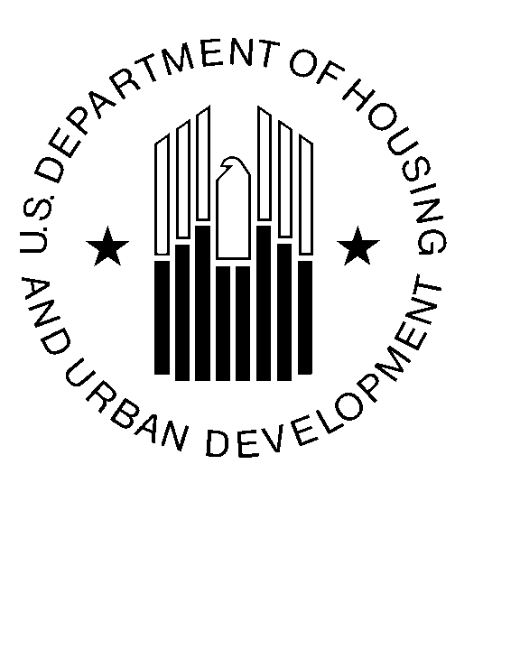

U.S. Department of Housing and Urban Development

December 1, 2007

James E. Wills, Vice President of Operations
Wills Management Group
1234 New York Avenue, N.E.
Washington, D.C. 20015

Re: Comprehensive Management Review Report
Capital Heights Apartments
FHA #000-35333

Dear Mr. Wills:

On October 1, 2007, a comprehensive Management Review of Capital Heights Apartments was conducted by my staff. The on-site review resulted in a Below Average rating based on deficiencies in financial management, specifically the rolling default of the mortgage.

Based on documentation you provided and our review of the documents, we have confirmed that the mortgage is now current and in compliance with HUD business agreements. Accordingly, this finding has been resolved and will be closed out in HUD systems.

If you have any questions, please contact the Project Manager, Senior Project Manager at (202) 575-5700 ext. 8000 or by email at: ProjectManager@hud.gov.

Sincerely,

(Name)
Multifamily Hub Director

