HUD Regional Administrator Attends First Choice Market Groundbreaking
Made Possible through $3.1 Million in HUD Recovery Act Funding
Full Service Grocery Brings Fresh Food Choices for Economically Underserved Community

Southeast Regional Administrator Ed Jennings, Jr., Congressman John Yarmuth (KY-D-3), Louisville Metro Mayor Jerry Abramson and other dignitaries broke ground on the new First Choice Market in Park DuValle on November 23, 2010, which promises to be the first full service grocery store for the community in over a decade. The store, which is set to open in June 2011, will be 20,000 square feet located at the 3000 block of Wilson Avenue.

First Choice Market will be operated by locally owned ValuMarket. The $4.4 million project was made possible by a $3.1 million HUD Recovery Act Community Development Block Grant.

By offering the community fresh, wholesome food choices it marks the beginning of a better quality of life for the citizens in the area. “Every child needs a place where their mother can go and get fruits and vegetables,” said Ed Jennings Jr. He also said the project would not have been possible without Abramson’s vision and local officials and community leaders working with folks in Washington, D.C. “It always starts on the ground,” Jennings said of the collaboration of the local community leaders.

This project will also open the door for economic development since approximately 200 construction jobs will be created, as well as over 30 full time permanent positions once the store has been completed.

Find more information on the HUD Community Development Block Recovery Grant.

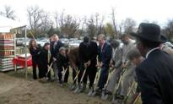Groundbreaking

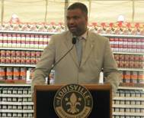Ed Jennings, Jr.

Ed Jennings, Jr., and Louisville Metro Mayor Jerry Abramson

