U.S. Department of Housing
and Urban Development

Chief FOIA Officer Report
March 2012

Background

The Department of Housing and Urban Development’s FOIA operations are decentralized due to the decentralized nature of various program areas and the consequent geographic dispersion of documents responsive to FOIA requests. HUD officials who have primary responsibility for the administration of program areas are located at HUD Headquarters in Washington, D.C. However, numerous programs are administered at the local level through 10 Regional Offices, headed by Regional Directors who oversee the operation of all HUD program areas in their jurisdiction. In addition, certain program areas and functions have been centrally sited in areas outside of Washington, D.C. For example, single family homeownership programs are operated by HUD “Home Ownership Centers” (HOCs) located in Atlanta, Georgia, Philadelphia, Pennsylvania, Santa Ana, California, and Denver, Colorado. HUD’s National Servicing Center, which provides lender assistance and asset management functions, is centrally located in Oklahoma City, Oklahoma. The Department’s debt collection activities related to home improvement loans and manufactured housing are operated out of a HUD center in Albany, New York.

Section I: Steps Taken to Apply the Presumption of Openness

The Department continues to discuss best practices and facilitate dialogues among the various program offices and FOIA Liaisons related to the current Administration’s guidance. Copies of President Obama’s March 16, 2009, FOIA Memorandum and Attorney General Holder’s FOIA Guidelines were distributed to all HUD FOIA Liaisons Department-wide and have been posted on HUD’s internal website.
HUD has long sought to comply with the spirit of the FOIA and to always release where possible. The Department’s reviewing officials and FOIA staff, along with its Office of General Counsel, where appropriate, meticulously review responsive records with a clear presumption in favor of release. Pursuant to the Department’s requirement, no FOIA exemption may be invoked to withhold a record or portion of a record unless prior concurrence by agency counsel is obtained. FOIA specialists and attorneys are routinely available to recommend to program office staff that they consider releasing records even when a FOIA exemption would authorize the withholding of such records. HUD proudly recognizes its Boston, Chicago, Fort Worth, and Kansas City offices for not withholding or denying any records in their entirety in FY 2011. HUD’s Seattle Regional Office released records that were previously withheld under Exemption 2 of the FOIA, and the Philadelphia Office made discretionary releases under Exemption 5. In addition, HUD Headquarters and Field Office staff continue to release drafts, handwritten notes, and emails that would have customarily been withheld under Exemption 5 of the FOIA and ask submitters of records to clearly state the harm in release before a determination is made to withhold.

To ensure openness and consistency, Office of the Executive Secretariat staff, in conjunction with the Office of General Counsel, updated the Department’s FOIA regulations from those used in 2007. The revised regulations will provide a cornerstone for training that will be provided to liaisons across the Department.

HUD’s Hartford Office in collaboration with the Office of Field Policy and Management conducted FOIA training that included discretionary releases. In addition, Headquarters FOIA staff attended courses provided by the Department of Justice, such as the FOIA Litigation Seminar, FOIA for Attorneys and Access Professionals, Privacy Act for FOIA/Access Professionals, and FOIA Exemption 2 training.

HUD notably increased the number of requests granted in full by 85 percent from FY 2009 to
FY 2010. However, the Department experienced slight decreases in its full and partial disclosures, as well as an increase in full denials, in comparison to last year. HUD decreased its disclosure of full grants by 18 percent, from 1,291 in FY 2010 to 1,055 in FY 2011; decreased the instances in which it released records in part by 23 percent, from 542 to 415; and increased the number of instances in which it denied information in full by 13 percent, from 70 to 79. However, no records were denied in full by four of HUD’s Regional Offices last year.

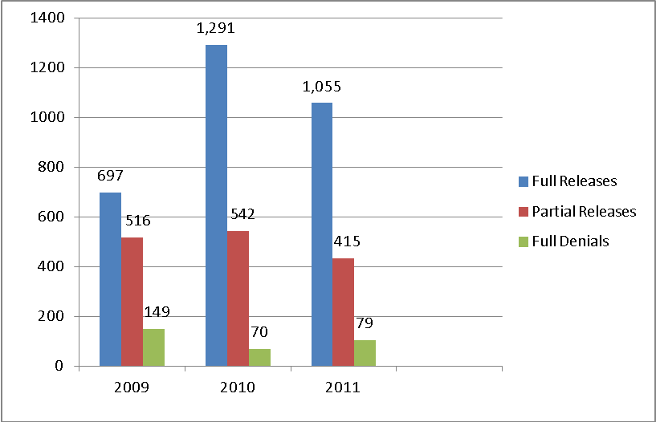

Section II. Steps Taken to Ensure the Agency has an Effective System for
Responding to Requests

As a result of conducting a business process reengineering to find ways to standardize and improve upon the efficiency of the Department’s current FOIA process, HUD conducted a pilot in hopes of significantly reducing the number of steps in the current process. The pilot was successful and has been implemented. In addition, HUD completed a Standard Work Flow document (FOIA Checklist), which will soon be disseminated throughout the Department. Headquarters will also be posting additional reference material and instructions on its internal website to ensure uniformity.

The management of the FOIA function changed in 2010 and an assessment of staffing, workload, backlogs, and efficiency was conducted. A determination was made to invest in upgrading the systems that support the function, to include an electronic FOIA tracking system. The Department kept its commitment to upgrade its electronic FOIA tracking system. Training was provided the week of September 26, 2011, to all Headquarters and Field FOIA Liaisons, including to a number of program subject matter experts and members of management who had not been previously trained. An outside contractor provides support and maintenance for the system and can remotely resolve any problems. HUD’s Help Desk troubleshoots as well. Functional efficiency is currently being monitored.

The senior management of HUD continues to meet regularly to track progress and provide assistance as needed. Open Government staff is included in these meetings. The Chief FOIA Officer also works closely with HUD’s Open Government Team and holds regular meetings with Departmental FOIA contacts.

Section III: Steps Taken to Increase Proactive Disclosures

HUD’s FOIA website currently contains useful information on how to file a FOIA request, as well as some basic user-friendly information on the FOIA process. It also contains the required electronic reading room with a link to a “Frequently Requested Materials” section. In FY 2011, the Department posted additional information on its FOIA website, such as 2009 and 2010 FOIA log reports, mutual mortgage insurance information, highest scoring 2010 funded grant applications, FOIA appeal instructions, and a link to online statuses of individual FOIA requests. HUD Headquarters FOIA Office designated one of its FOIA Specialists to review incoming requests to identify frequently requested documents and to work closely with program staff to identify additional records that can be made available to the public. Before submitting requests for records, requesters are encouraged, via the Department’s website, to first visit the Frequently Requested Documents list for records previously posted to the website.

Section IV: Steps Taken to Greater Utilize Technology

The majority of FOIA requests received are submitted to the Department electronically via HUD’s electronic FOIA Management System, which tracks, stores, retrieves, and allows staff to redact responsive documents electronically. It also keeps track of FOIA processing statistics and fees, and generates reports on the number, type, and disposition of FOIA requests processed, as required by the U.S. Department of Justice. HUD also uses its FOIA Management System to prepare the Annual FOIA Report. All of HUD’s components currently use this electronic tracking system. In addition, HUD has a component of the FOIA Management System that is designed to meet Executive Order requirements and openness in government. Together, the public can submit and track the status of FOIA requests over the Internet. Because requests submitted via the Internet are delivered to the FOIA Management System automatically, data entry time is greatly reduced. As a result, communication with the public is automated and expedited. Upgrades to HUD’s electronic FOIA Management System mentioned above will aid in facilitating overall efficiency, to include improving search capabilities.

The Office of the Executive Secretariat works closely with the Office of the Chief Information Officer, which handles IT support, to conduct New User and Refresher Training for its FOIA Liaisons and FOIA Specialists on the FOIA Management System. This training also includes some discussion and training on FOIA guidelines and procedures. The Executive Secretariat has identified additional staff who are proficient in utilization of the system to hold one-on-one sessions as needed.

Section V: Steps Taken to Reduce Backlogs and Improve Timeliness in
Responding to Requests

HUD reduced its backlogged requests by 30 percent, from 182 in FY 2010 to 128 in FY 2011, and closed 8 of its 10 oldest FOIA requests. HUD also reduced its pending administrative appeals by 85 percent, from 13 in FY 2010 to 2 in FY 2011, and closed 8 of its 10 oldest appeals. The remaining requests and appeals (two each) were not closed due to a reduction in staff, as well as the complexity of the requests.

To ensure effective and timely responses to all FOIA requests, HUD’s Chief FOIA Officer continues to assess workload, capability, and output of the office. She recommends changes in the structure of the workgroup and was instrumental in obtaining and implementing an upgraded electronic FOIA tracking system, which is currently being utilized Department-wide. The Chief FOIA Officer also sets regular backlog reduction goals and ensures that HUD meets and/or exceeds those goals. Increased monitoring allowed the Department to address and/or resolve any potential concerns earlier in the process.

HUD utilizes a separate track for simple requests. The average number of days to process simple requests Department-wide was 28 days.

To better target more efficient searches, HUD offices actively communicate with requesters via telephone and/or email to effectively refine the scope of requests. FOIA specialists/liaisons have also increased communication with requesters and have become more proactive.

The streamlined process is currently being reviewed for efficiency and consistency among all offices. Template letters have been reviewed and streamlined in an effort to improve response time as well.

The Department has not has not received any consultations from other agencies.

Use of FOIA’s Law Enforcement “Exclusions”

HUD did not invoke any statutory exclusions.

Spotlight on Success

HUD made significant progress in its continuing efforts to improve processing of FOIA requests. Over the last 6 years, the Department reduced the number of pending FOIA requests by 97 percent, from 4,941 to 128, including a 30 percent reduction in its backlog from FY 2010 to
FY 2011 (182 to 128).

Departmental Backlogged Requests

