

U.S. Department of Housing
and Urban Development

Chief FOIA Officer Report
March 2011

Background
HUD’s FOIA operations are decentralized due to the decentralized nature of various program areas and the consequent geographic dispersion of documents responsive to FOIA requests. HUD officials who have primary responsibility for the administration of program areas are located at HUD Headquarters in Washington, D.C. However, numerous programs are administered at the local level through 10 Regional Offices, headed by Regional Directors who oversee the operation of all HUD program areas in their jurisdiction. In addition, certain program areas and functions have been centrally sited in areas outside of Washington D.C. For example, single family homeownership programs are operated by HUD “Home Ownership Centers” (HOCs) located in Atlanta, Georgia, Philadelphia, Pennsylvania, Santa Ana, California, and Denver, Colorado. HUD’s National Servicing Center, which provides lender assistance and asset management functions, is centrally located in Oklahoma City, Oklahoma. The Department’s debt collection activities related to home improvement loans and manufactured housing are operated out of a HUD center in Albany, New York.
Transactional documents, such as those relating to closings on HUD’s multifamily properties, are located in over 50 local HUD field offices nationwide. The geographic dispersion of records that results from this decentralized organizational structure presents some unique challenges with respect to the management of HUD’s FOIA operations and to providing a uniform approach to how FOIA requests are addressed.
- Steps Taken to Apply the Presumption of Openness.

The Department continues to discuss best practices and facilitates dialogues among the various program offices and FOIA Liaisons related to the current Administration’s guidance. Copies of President Obama’s March 16, 2009, FOIA Memorandum and Attorney General Holder’s FOIA Guidelines were distributed to all HUD FOIA Liaisons Department-wide. In addition, this guidance will be posted on HUD’s internal website, along with other relevant materials.
HUD has long sought to comply with the spirit of the FOIA and to always release where possible. Its reviewing officials and FOIA staff, along with its Office of General Counsel where appropriate, meticulously reviews responsive records with a clear presumption in favor of release. Pursuant to the Department’s requirement, no FOIA exemption may be invoked to withhold a record or portion of a record unless prior concurrence by agency counsel is obtained. An attorney is routinely available to recommend to program office staff that they consider releasing records even when a FOIA exemption would authorize the withholding of such records.

In FY 2009, the Department began releasing drafts and handwritten notes that would have customarily been withheld under Exemption 5 of the FOIA. In some cases where the Department ordinarily withheld records under Exemption 4, it now asks the submitters of those records to clearly state the harm in release before a determination is made to withhold. In FY 2009, HUD’s Denver Office released records that were previously withheld under Exemption 2. HUD is proud to state that in FY 2009 its Nashville and Milwaukee Offices granted in full all of its requests for records and the Pittsburgh Office granted all requests for records in full with the exception of one, as the records sought did not exist. The Omaha Office had no FOIA requests that were not released in full in both FY 2009 and FY 2010.

In FY 2010, eight of HUD’s ten Regional Offices did not withhold or deny any records in their entirety under the FOIA. The Seattle Regional Office made discretionary releases pertaining to information in fair housing case files that were previously withheld under Exemption 2. The New England Regional Office made discretionary releases pertaining to information that would customarily be withheld under Exemption 5.

Some of HUD’s field offices conducted training in their respective offices to brief all employees on FOIA requirements and the specific role of each program office to ensure openness. The Anchorage Field Office developed a comprehensive presentation, stressing the importance of the President’s FOIA Memorandum and the Attorney General’s Guidelines and has amended their existing training materials to include the main points in both the President’s Memorandum and the Attorney General’s Guidelines. The Los Angeles Field Office developed a standard FOIA operating procedures guidebook on the topic of the presumption of openness.

HUD made significant progress in increasing disclosures. The Department increased its disclosure of full grants by 85 percent, from 697 in FY 2009 to 1,291 in FY 2010. HUD increased the instances in which it released material in part by 5 percent, from 516 to 542. In addition, the number of instances in which HUD denied information in full decreased by 53 percent, from 149 to 70.

Disposition of FOIA Requests
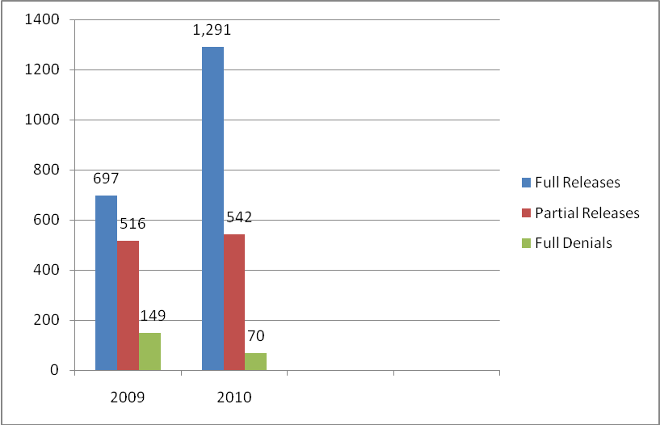

- Steps Taken to Ensure the Agency has an Effective System for Responding to Requests.

The Department has made a major commitment to upgrade its systems for processing FOIA requests Department-wide. The upgrades will be acquired during FY 2011 and the anticipated result is significantly greater efficiency and timeliness in responding to requests.
As a result of the President’s Open Government Initiative, the senior management of HUD now meets regularly with FOIA staff to track progress and provide assistance as needed. Open Government staff is included in these meetings to keep the FOIA staff apprised of Open Government activities that might be related and to make suggestions as needed.
As a result of a recent business process reengineering to find ways to standardize and improve upon the efficiency of the Department’s current FOIA process, HUD conducted a pilot in hopes of significantly reducing the number of steps in the current process. The pilot is currently being reviewed for possible implementation. In addition, HUD created and is assessing a draft FOIA Standard Work Flow process for distribution and use Department-wide. Headquarters will soon be posting additional reference material and instructions to its internal website to ensure uniformity agency-wide.
The management of the FOIA function changed in 2010 and an assessment of staffing, workload, backlogs, and efficiency was conducted. A determination was made to invest in upgrading the systems that support the function and could mitigate the need to increase staff. Once the upgraded system is acquired, functional efficiency will be monitored to determine if staffing changes are needed.

- Steps Taken to Increase Proactive Disclosures.

HUD’s FOIA website currently contains useful information on how to file a FOIA request, as well as some basic user-friendly information on the FOIA process. It also contains the required electronic reading room with a link to a “Frequently Requested Materials” section and lists items that provide information to those seeking records pertaining to HUD programs, such as the Federal Housing Administration (FHA) approved lenders, homes for sale, FHA mortgage insurance programs, multifamily housing data, testimonies before Congress, press releases, final opinions and orders, and hearings and appeals. HUD has recently added some of the FY 2009 highest scoring funding grant applications to the website. Additional FY 2009 grants will be posted along with FOIA request logs. FOIA request logs are often reviewed to identify frequently requested materials to be posted to the website. The Department continues to work closely with program staff to identify additional records that can be made available to the public.

- Steps Taken to Greater Utilize Technology.

The Department currently uses a FOIA management tracking system, which electronically tracks, stores, retrieves, and redacts requests. It also keeps track of FOIA processing statistics and fees, and generates reports on the number, type, and disposition of FOIA requests processed, as required by the U.S. Department of Justice. HUD also uses its FOIA management tracking system to prepare the Annual FOIA Report. All of HUD’s components currently use this electronic tracking system. In addition, HUD has a component of the FOIA management tracking system that is designed to meet Executive Order requirements and openness in government. Together, the public can submit and track the status of FOIA requests over the Internet. Because requests submitted via the additional component are delivered to the FOIA management tracking system automatically, data entry time is greatly reduced. These systems also automate and expedite communication with the public. The Department, however, is in the process of soliciting awards for upgrades to the system.
The Office of the Executive Secretariat works closely with the Office of the Chief Information Officer, which handles IT support, to conduct New User and Refresher Training for its FOIA Liaisons and FOIA Specialists. This training also includes some discussion and training on FOIA guidelines and procedures.

- Steps Taken to Reduce Backlogs and Improve Timeliness in Responding to Requests.

HUD reduced its backlogged requests by 55 percent compared to FY 2009, from 406 to 182. Additionally, HUD has closed 8 of its 10 oldest pending requests. The Department ended FY 2009 without any pending administrative appeals. However, FY 2010 ended with a backlog of 11 appeals, as a result of an increase in the number of appeals received. Four of the eleven are now closed.

In March 2010, the office acquired a new Chief FOIA Officer, who conducted a full assessment of the workload, capability, and output of the office. She recommended changes in the structure of the workgroup and improvements in the software used to process requests. To ensure effective and timely responses to all FOIA requests, HUD’s Chief FOIA Officer continues to set regular backlog reduction goals and has ensured that HUD has met and/or exceeded those goals. Increased monitoring has allowed the Department to address and/or resolve any potential concerns earlier in the process. FOIA requests are also discussed more often at senior management meetings. HUD has not determined that an increase in FOIA staffing is necessary at this time. Improvements in IT, however, have been implemented to increase timeliness.
To better target more efficient searches, HUD offices actively communicate with requesters via telephone and/or email to effectively refine the scope of the request.

The current FOIA process has been reviewed to identify opportunities for streamlining the steps in processing requests and encourage consistency among program offices.

Spotlight on Success

HUD made significant progress in its continuing efforts to improve the processing of FOIA requests. For example, over the last five years, the Department reduced the number of pending FOIA requests by more than 90 percent, from 4,941 to 182. HUD also applied the presumption of openness with respect to FOIA requests as directed by President Obama and Attorney General Holder in 2009. Consequently, the number of requests granted in full increased by more than 85 percent from FY 2009 to FY 2010. In addition, 8 of 10 Regional Offices did not withhold any records in their entirety.

